**DAILY ONLINE ACTIVITIES SUMMARY**

|  |  |  |  |  |  |  |  |  |
| --- | --- | --- | --- | --- | --- | --- | --- | --- |
| **Date:** | **16/06/2020** | | | | | **Name:** | **Hanan Saleem Baji** | |
| **Sem & Sec** | **4th SEM 'A' Section** | | | | | **USN:** | **4AL18CS024** | |
| **Online Test Summary** | | | | | | | | |
| **Subject** | | Maths | | | | | | |
| **Max. Marks** | | 30 | | **Score** | | | 26 | |
| **Certification Course Summary** | | | | | | | | |
| **Course** | **1.Cloud Foundation** | | | | | | | |
| **Certificate Provider** | | | **1. Great Learning Academy** | | **Duration** | | | **1. 3 hour** |
| **Coding Challenges** | | | | | | | | |
| **Problem Statement:** 1. Write a C program to implement the binary reversal.  2. Write a Python program to check whether a given a binary tree is a valid binary search tree (BST) or not?  .  For example | | | | | | | | |
| **Status: completed** | | | | | | | | |
| **Uploaded the report in Github** | | | | | **Yes** | | | |
| **If yes Repository name** | | | | | 1. <https://github.com/saleemhananbaji/C-coding> 2. <https://github.com/saleemhananbaji/Python-Coding> | | | |
| **Uploaded the report in slack** | | | | | **Yes** | | | |

ONLINE TEST DETAILS: Online test was conducted on first module of **Maths**. Test contains 30 questions of 1 mark each. I have scored 26 Marks.

Snapshot:

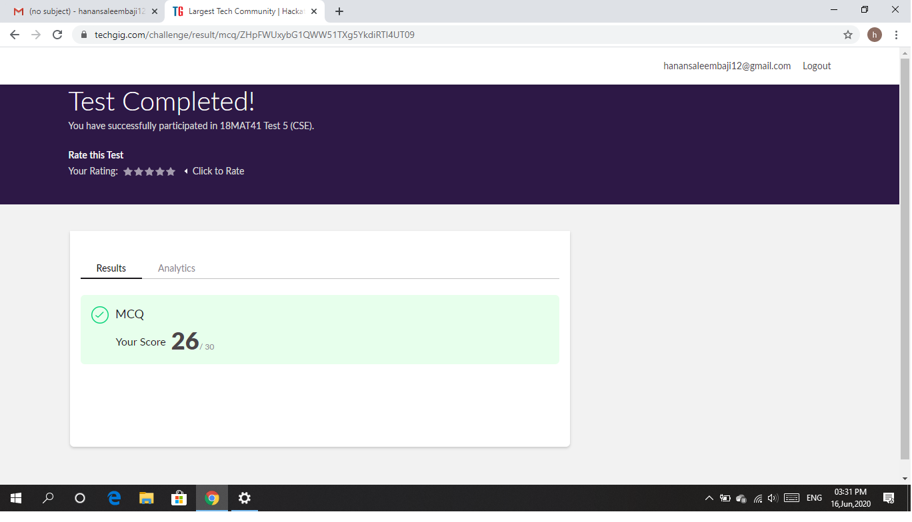

Certification Course Details: As the continuation of online course, I have completed Cloud attributes, Managed services and Deployment models in cloud foundations.

Snapshot:

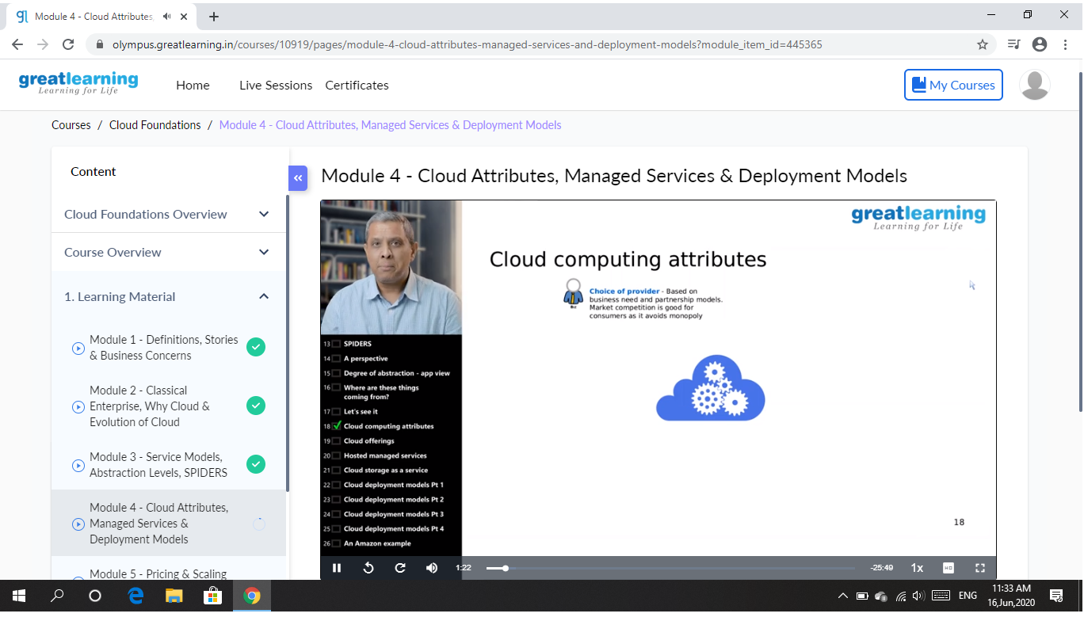

CODING CHALLENGES DETAILS: Problem statements

1. Write a C program to implement the binary reversal.

Solution: Uploaded it in github

Snapshot:

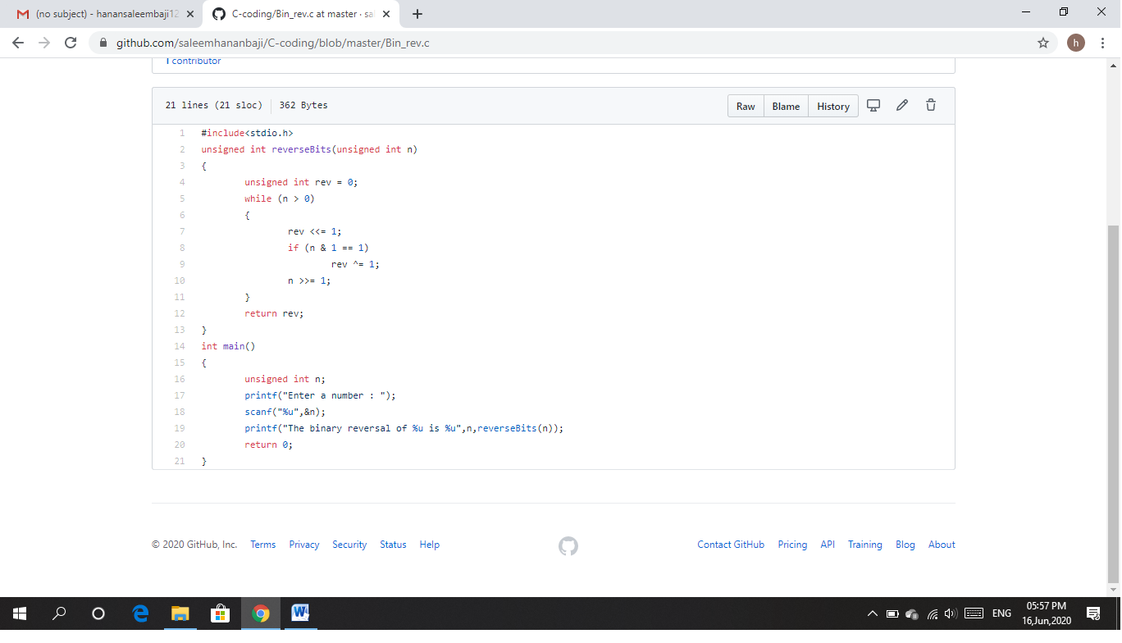

1. Write a Python program to check whether a given a binary tree is a valid binary search tree (BST) or not?

Solution: Uploaded it in github

Snapshot:

